**Berlin's Top 10 Attractions**

Are you on a whistle-stop tour of the capital or just looking for the **Berlin Top 10**? Well look no further, because we've picked the top ten things to see and do in Berlin so you don't have to. The choice of the top 10 Berlin attractions was by no means easy - this city has so much to offer! But here are the top 10 attractions and places you do have to visit in Berlin.

**Top pick 1: Reichstag & glass dome**

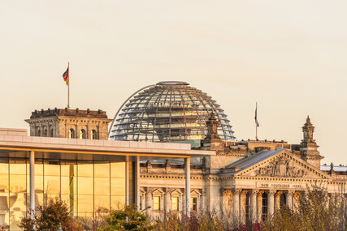Reichstag with dome © visitBerlin, Foto: Dagmar Schwelle

When the decision was made to move the Federal Government to Berlin, it was time to reawaken the [**Reichstag**](https://www.visitberlin.de/en/reichstag-in-berlin) building from its long years of slumber on the Mauerstreifen, the military zone between the two sides of the Wall. The building has since been completely modernised, and today's visitors to the Reichstag can look out from the building's glass dome to get a bird's eye view of the hustle and bustle in the city. There are also a number of government buildings in the vicinity of the Reichstag, for example the **Bundeskanzleramt** ([**Federal Chancellery**](https://www.visitberlin.de/en/german-chancellery)) and the [**Brandenburg Gate**](https://www.visitberlin.de/en/brandenburg-gate).

Experience the government district and many other highlights from the water with a boat tour:

[**TICKETS FOR BOAT TOURS**](https://www.visitberlin.de/en/tickets-boat-tours-river-cruises-berlin)

**Top pick 2: Brandenburg Gate - Berlin's signature attraction**

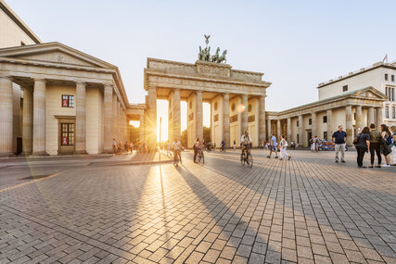Brandenburg Gate © visitBerlin, Foto: Dagmar Schwelle

Without a doubt, the [**Brandenburg Gate**](https://www.visitberlin.de/en/brandenburg-gate) is Berlin's signature attraction. Built in 1791, it was just one of many old city gates around the city of Berlin which, at that time, was still a manageable size. The decorative Pariser Platz was laid at the foot of the gate and is now home to many of the city's important buildings, for example, the **Hotel Adlon** with its wealth of history and the **[Akademie der Künste](https://www.visitberlin.de/en/akademie-der-kunste" \o "Akademie der Künste)** (Academy of the Arts).

**Top pick 3: Berlin Television Tower (Fernsehturm) - Berlin's highest attraction**

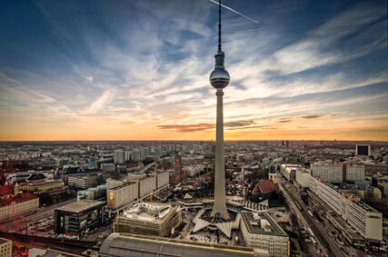Television tower in Berlin © iStock.com

The [**Berlin Television Tower**](https://www.visitberlin.de/en/berlin-television-tower), which is known to locals as the **Fernsehturm**, and is instantly recognisable from the distance, stand outs of the skyline at 368m, making it the tallest building and by far highest tourist attraction in Berlin. Built in the 1960s, visitors to the tower can enjoy a unique 360° panorama of the city. **Tip:** Visit the TV Tower with the [**Berlin Welcome Card**](https://www.visitberlin.de/en/berlin-welcome-card) and save up to 25 per cent. The Berlin WelcomeCard enables free travelling with all public transport services to the Berlin visitors. With over 200 partners and outstanding discounts the Berlin WelcomeCard offers you a complete „carefree“ package.

[**TICKETS FOR TV-TOWER & RESTAURANT SPHERE**](https://www.visitberlin.de/en/tickets-berlin-tv-tower-and-restaurant-sphere)

[**BERLIN WELCOME CARD**](https://www.visitberlin.de/en/berlin-welcome-card)

Advertisement

Skeletons begin to dance, Rubens' angel slips out of his painting and a thumb-sized chef hops straight onto the visitor's plate - all works of art made of light. The Belgian artist duo SKULLMAPPING presents entertaining and fascinating projections as well as impressive video art in an innovative exhibition.

[**TICKETS & DATES**](https://projectedart.de/?source=bde)

**Top pick 4: Humboldt Forum - always a great place to visit**

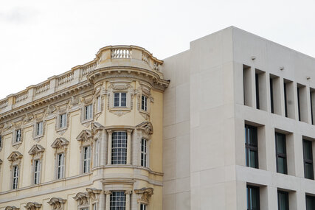South and east façade of the Humboldt Forum © Foto: Sönke Schneidewind

Directly opposite Berlin's [**Museum Island**](https://www.visitberlin.de/en/museum-island-in-berlin), a new cosmopolitan forum for culture, art and science has opened in the heart of the capital: the[**Humboldt Forum**](https://www.visitberlin.de/en/humboldt-forum). Visible from afar, it covers an area of around 30,000 square metres. The reconstructed baroque palace facades shine in bright quince yellow. State-of-the-art interactive exhibitions await you under one roof and spread over five floors. Since September 2021, the world-famous collections of the Ethnological Museum and the Museum of Asian Art are also on display here.

Also take a look around the corner from the Humboldt Forum: The **[Friedrichswerder Church](https://www.visitberlin.de/en/friedrichswerdersche-kirche" \o "Friedrichswerdersche Kirche" \t "_blank)**, built by Schinkel, is now a very special museum, displaying sculptures of classicism in the high neo-Gothic church hall.

**Top pick 5: Gendarmenmarkt - Berlin's most beautiful attraction**

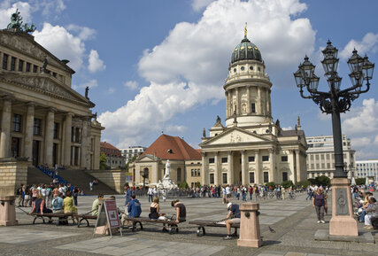Konzerthaus (Concert Hall) and Französischer Dom (French Cathedral) © visitBerlin, Foto: Wolfgang Scholvien

The **[Gendarmenmarkt](https://www.visitberlin.de/en/gendarmenmarkt" \o "Gendarmenmarkt in Berlin)** is one of the most stunning squares in the city, located close to **[Friedrichstraße](https://www.visitberlin.de/en/friedrichstrasse" \o "Friedrichstraße in Berlin)**, Berlin's exclusive shopping street in the central Mitte district. Three of the most impressive examples of architecture in the capital city are to be found here: the Concert House designed by Schinkel and the German and French Cathedrals (the **[Deutscher Dom](https://www.visitberlin.de/en/deutscher-dom" \o "German Cathedral in Berlin)** and the **[Französischer Dom](https://www.visitberlin.de/en/franzosischer-dom-french-cathedral" \o "French Cathedral in Berlin)**).

Combine your visit to Gendarmenmarkt with a city tour and discover other top sights:

[**TICKETS FOR HOP-ON HOP-OFF BUS TOURS**](https://www.visitberlin.de/en/tickets-hop-on-hop-off-sightseeing-bus-tours-berlin)

**Top pick 6: Kurfürstendamm - Berlin's most famous shopping street**

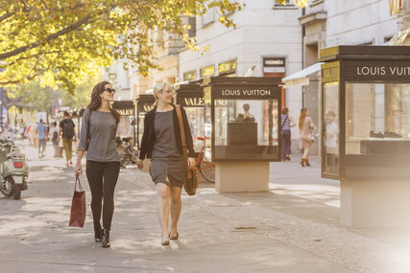Shopping at Kurfürstendamm © visitBerlin, Foto: Dagmar Schwelle

Extending all the way from the ruins of the [**Kaiser Wilhelm Memorial Church**](https://www.visitberlin.de/en/kaiser-wilhelm-memorial-church) on Breitscheidplatz to Berlin's elegant Halensee neighbourhood, the affectionately termed **[Kurfürstendamm](https://www.visitberlin.de/en/kurfurstendamm" \o "Kurfürstendamm in Berlin)** is the most expensive address in the capital city and home to the most exclusive brands. Europe's biggest department store KaDeWe is also situated on the extension of the Ku'damm, on the street known to locals as the Tauentzien (short for Tauentzienstrasse). You will find many sights and top attractions along this famous shopping street. The little ones will just love the [**Zoo Berlin**](https://www.visitberlin.de/en/zoo-berlin), Germany's oldest zoo.

[**DAY-TICKETS FOR ZOO BERLIN**](https://www.visitberlin.de/en/tickets/zoo-berlin-day-ticket)

**Top pick 7: Charlottenburg Palace**

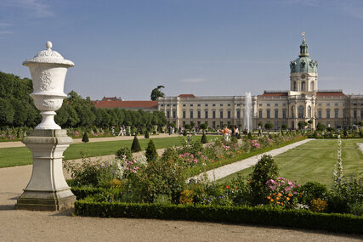Park of Charlottenburg Palace © visitBerlin, Foto: Wolfgang Scholvien

Schlossgarten Charlottenburg

The magnificent **[Charlottenburg Palace](https://www.visitberlin.de/en/charlottenburg-palace-old-palace" \o "Charlottenburg Palace in Berlin)** is located just out of the centre of the city. The beautiful palace hosts fine collections of china and paintings and is situated in the middle of a picturesque palace garden right next to the river Spree. If you don't fancy a walk in the park, you can feed your mind instead in the **Charlottenburg museums** located directly opposite. Make sure to go on a stroll through the extensive park after visiting this very royal Berlin attraction.

**Top pick 8: Museum Island**

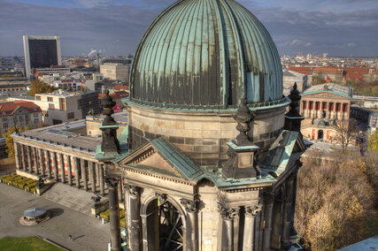Museum Island-Altes Museum © visitBerlin, Foto: Wolfgang Scholvien

Berlin's [**Museum Island**](https://www.visitberlin.de/en/museum-island-in-berlin) is one of the UNESCO world heritage sites and home to the city's most important exhibition centres: the **[Altes Museum](https://www.visitberlin.de/en/altes-museum-old-museum" \o "Old Museum in Berlin)** (**Old Museum**), the **[Neues Museum](https://www.visitberlin.de/en/neues-museum-new-museum" \o "New Museum in Berlin)** (**New Museum**) the [**Bode Museum**](https://www.visitberlin.de/en/bode-museum), the **[Pergamon Museum](https://www.visitberlin.de/en/pergamon-museum" \o "Pergamon Museum in Berlin)** and the **[Alte Nationalgalerie](https://www.visitberlin.de/en/alte-nationalgalerie-old-national-gallery" \o "Old National Gallery in Berlin)** (**Old National Gallery**). The collections in these buildings encompass over 6,000 years of art and cultural history.

Just opposite Berlin's Museum Island, the magnificent monumental [**Berlin Cathedral,**](https://www.visitberlin.de/en/berlin-cathedral) an important landmark of Berlin whose history dates back to the 15th century, is also located on the Museum Island.

**Tip:** Visit Berlin's museums with the [**3-day Berlin Museum Pass**](https://www.visitberlin.de/en/museum-pass-berlin). For €29 (reduced €14.50), the museum pass guarantees free admission for all Berlin visitors on three consecutive days to many museums. Order now in the visitBerlin-Shop

[**TICKETS FOR THE MUSEUM PASS**](https://www.visitberlin.de/en/tickets/3-days-museum-pass-berlin-more-30-museums)

**Top pick 9: The Berlin Wall Memorial and Documentation Centre**

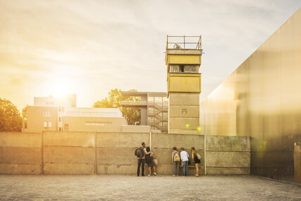Berlin Wall Memorial in warm light © visitBerlin, Foto: Dagmar Schwelle

The **[Gedenkstätte Berliner Mauer](https://www.visitberlin.de/en/berlin-wall-memorial" \o "Berlin Wall Memorial in Berlin)** (**Berlin Wall Memorial**) is located between the districts of Wedding and Mitte on Bernauer Straße, consisting of the Memorial to the Victims of the Wall, a Documentation Centre and the Chapel of Reconciliation. The surviving section of the wall and watchtower enable visitors to get a real feel for the reality of the border facilities. A must see Berlin attraction, not only for visitors interested in Beriln's history.

Get to know more about the Berlin wall at the [**East Side Gallery**](https://www.visitberlin.de/en/east-side-gallery).

**Top pick 10: Victory Column - magnificent view on Berlin**

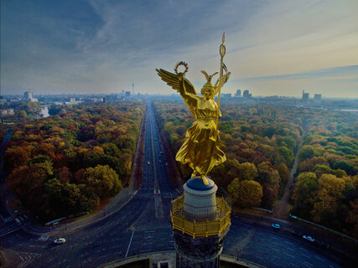Victory Column in Tiergarten © Getty Images, Foto: André Berg / Eye Em

The [**Berlin Victory Column**](https://www.visitberlin.de/en/siegessaule) is one of the most famous landmarks of the German capital.  
The 67-metre-high column, crowned by the golden Berlin Peace Angel, the "Goldelse", visible from afar, stands in the middle of the Tiergarten. From the platform you have a magnificent view over the parklands of the Tiergarten and over the whole of Berlin.  
The Victory Column was erected in the 19th century and originally commemorated Germany's wars of unity. Today it has become a symbol of peace.

From the Victory Column you can walk in the **[Tiergarten](https://www.visitberlin.de/en/tiergarten" \o "Tiergarten)** but also walk to the nearby [**Brandenburg Gate**](https://www.visitberlin.de/en/brandenburg-gate), **[Potsdamer Platz](https://www.visitberlin.de/en/potsdamer-platz" \o "Potsdamer Platz)** or the[**Berlin Reichstag**](https://www.visitberlin.de/en/reichstag-in-berlin).

Source: [Berlin's Top 10 Attractions - places to visit in Berlin | visitBerlin.de](https://www.visitberlin.de/en/berlins-top-10-attractions)